**DATABASE MANAGEMENT SYSTEM CASE STUDY**

**SEMESTER IV**

**TEAM MEMBERS:**

PRAMOTH KANNA P - 1907030

NAGA DEEPAN G S – 1907025

**AIM:**

To design an application with backend database connectivity.

**FUNCTION:**

* Online Pizza Delivery
* Login / Sign Up
* Ordering a Pizza
* Admin panel
* Checking Deliveries

**Front End:** HTML, CSS, Bootstrap

**Back End:** Node Js, Express Js, MySQL

**Software Requirement :** XAMPP Server ,Visual Studio Code, MySQL

**ENTITY-RELATIONSHIP DIAGRAM:**

My Orders

Order

Customers

Gets Info

Products

**DATABASE NAME : PIZZA**

**TABLE NAME : CUSTOMERS**

|  |  |
| --- | --- |
| **COLUMN** | **TYPE** |
| User Id (Primary Key) | Int |
| User Name | Varchar(25) |
| Phone Number | Varchar(15) |
| DOB | Date |
| Password | Varchar(25) |

**TABLE NAME : PRODUCT**

|  |  |
| --- | --- |
| **COLUMN** | **TYPE** |
| Product Id (Primary Key) | Int |
| Product Name | Varchar(25) |
| Price | Int |
| Size Available | Varchar(25) |
| Image | Varchar(35) |

**TABLE NAME : MY ORDERS**

|  |  |
| --- | --- |
| **COLUMN** | **TYPE** |
| User Id | Int |
| Product Id | Int |
| Quantity | Int |
| Total Price | Int |
| Address | Varchar(55) |
| Mobile Number | Varchar(15) |

**DATABASE :**

**XAMP CONTROL PANEL :**

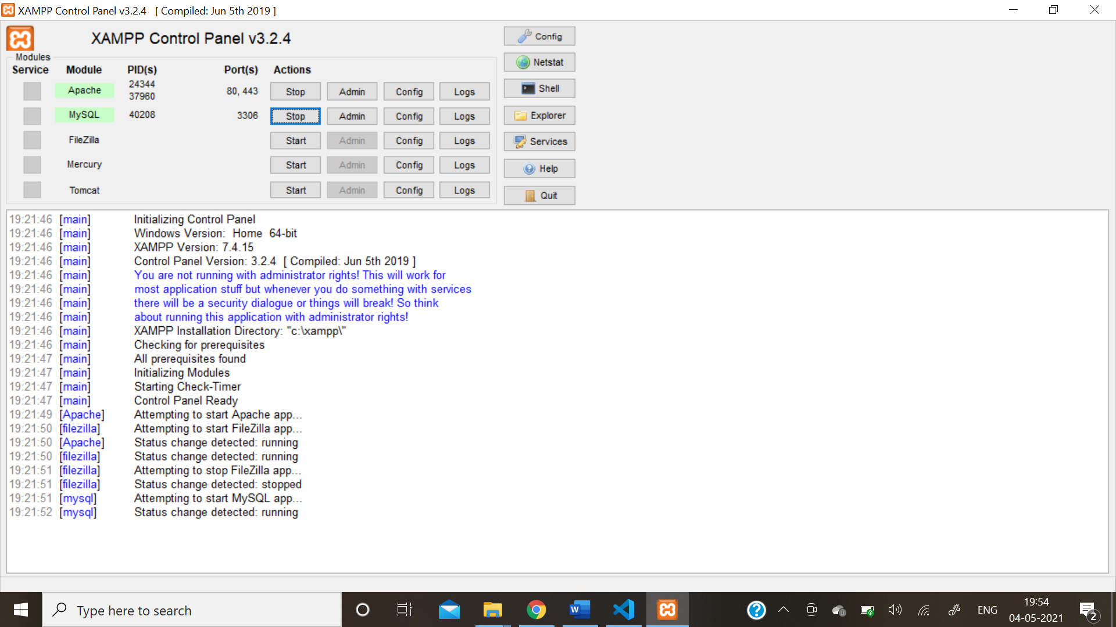

**DATABASE STRUCTURE:**

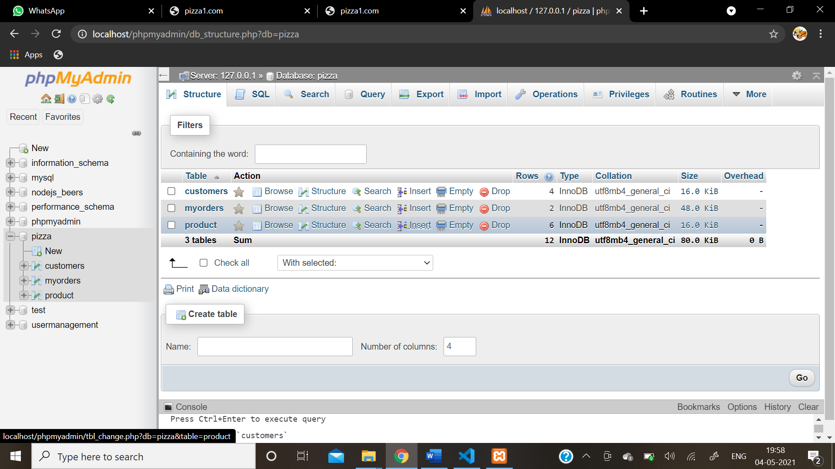

**BACK END :**

**PACKAGE:**

{

  "name": "nodejs-usermanagement",

  "version": "1.0.0",

  "description": "",

  "main": "index.js",

  "scripts": {

    "test": "echo \"Error: no test specified\" && exit 1",

    "start": "nodemon app.js"

  },

  "author": "",

  "license": "ISC",

  "dependencies": {

    "bcryptjs": "^2.4.3",

    "body-parser": "^1.19.0",

    "dotenv": "^8.2.0",

    "express": "^4.17.1",

    "express-handlebars": "^5.3.0",

    "mysql": "^2.18.1",

    "nodemon": "^2.0.7"

  }

}

**CODE:**

const express=require('express')

const mysql=require('mysql')

const exphbs=require('express-handlebars')

bodyParser=require('body-parser')

const app=express()

const port=2000

app.use(bodyParser.urlencoded({extended:false}))

app.use(bodyParser.json())

app.use(express.static("public"))

app.engine("hbs",exphbs({extname:".hbs"}))

app.set("view engine","hbs")

global.username;

global.userid;

global.productid;

const pool=mysql.createPool({

    connectionLimit  : 10,

    host             : 'localhost',

    user             : 'root',

    password         : 'pramoth6302',

    database         : 'pizza'

})

pool.getConnection((err,connection)=>{

    if(err) throw err;

    console.log(`Connected to Thread : ${connection.threadId}`)

})

app.get('/',(req,res)=>{

    res.render('login')

})

app.get('/admin',(req,res)=>{

    res.render('loginadmin')

})

app.get('/sign',(req,res)=>{

    res.render('signup')

})

app.post('/homepage',(req,res)=>{

    pool.getConnection((err,connection)=>{

        if(err) throw err;

        connection.query('SELECT * FROM customers WHERE name=? and password=?',[req.body.uname,req.body.password],(err,rows)=>{

            connection.release();

            if(!err){

                if(rows.password=req.body.password){

                    if(rows.name=req.body.uname){

                        res.render('home',{rows})

                    }

                    else{

                        res.render('login',{alert:"Username or Password seems invalid"});

                    }

                }else{

                    res.render('login',{alert:"Username or Password seems invalid"});

                }

            }else{

                console.log(err)

            }

        })

    })

})

app.post('/adminpage',(req,res)=>{

    pool.getConnection((err,connection)=>{

        if(err) throw err;

        connection.query('SELECT m.user_id,m.prod_id,c.name,p.prod_name,p.price,p.image,m.quantity,m.total_price,m.address FROM customers c,product p,myorders m where m.user_id=c.user_id and p.prod_id=m.prod_id',(err,rows)=>{

            connection.release();

            if(!err){

                if(req.body.password=="password"){

                    if(req.body.uname=="admin"){

                        res.render('admincart',{rows})

                    }

                    else{

                        res.render('loginadmin',{alert:"Admin Name or Password seems invalid"});

                    }

                }else{

                    res.render('loginadmin',{alert:"Admin Name or Password seems invalid"});

                }

            }else{

                console.log(err)

            }

        })

    })

})

app.get('/remove/:uid/:pid/:quan/:ad',(req,res)=>{

    pool.getConnection((err,connection)=>{

        uid=req.params.uid;

        pid=req.params.pid;

        quan=req.params.quan;

        ad=req.params.ad;

        if(err) throw err;

        connection.query('DELETE FROM myorders where user_id=? and prod_id=? and quantity=? and address=?',[uid,pid,quan,ad],(err,rows)=>{

            connection.release();

            if(!err){

                res.render('success',{alert:"The Order has been Delivered Successfully"})

            }else{

                console.log(err)

            }

        })

    })

})

app.get('/product/:id/:uname',(req,res)=>{

    userid=req.params.id;

    username=req.params.uname;

    pool.getConnection((err,connection)=>{

        if(err) throw err;

        connection.query('SELECT * FROM product',(err,rows)=>{

            connection.release();

            if(!err){

                   res.render('products',{rows,username})

            }else{

                console.log(err)

            }

        })

    })

})

app.get('/cart/:uname',(req,res)=>{

    uname=req.params.uname;

    pool.getConnection((err,connection)=>{

        if(err) throw err;

        connection.query('SELECT c.name,p.prod_name,p.price,p.image,m.quantity,m.total_price,m.address FROM customers c,product p,myorders m where c.name=? and m.user_id=c.user_id and p.prod_id=m.prod_id',[req.params.uname],(err,rows)=>{

            connection.release();

            if(!err){

                   res.render('cart',{rows})

            }else{

                console.log(err)

            }

        })

    })

})

app.post('/sign',(req,res)=>{

    const {uname,dob,mobile,password}=req.body;

    pool.getConnection((err,connection)=>{

        if(err) throw err;

        connection.query('INSERT INTO customers SET name=?,dob=?,mobile=?,password=?',[uname,dob,mobile,password],(err,rows)=>{

            connection.release();

            if(!err){

                res.render('signup',{alert:"User Added Successfully"});

            }else{

                console.log(err)

            }

        })

    })

})

app.get('/about',(req,res)=>{

    res.render('about')

})

app.get('/order/:id',(req,res)=>{

    productid=req.params.id;

    pool.getConnection((err,connection)=>{

        if(err) throw err;

        connection.query('SELECT * FROM product where prod_id=?',[req.params.id],(err,rows)=>{

            connection.release();

            if(!err){

                res.render('order',{rows,username})

            }else{

                console.log(err)

            }

        })

    })

})

app.post('/order/:price',(req,res)=>{

    const {mobile,quantity,address}=req.body;

    price=req.params.price;

    total=quantity*price;

    pool.getConnection((err,connection)=>{

        if(err) throw err;

        connection.query('INSERT INTO myorders SET user_id=?,prod_id=?,quantity=?,total_price=?,address=?,mobile2=?',[userid,productid,quantity,total,address,mobile],(err,rows)=>{

            connection.release();

            if(!err){

                res.render('success',{alert:"Your Order has been placed Successfully"})

            }else{

                console.log(err)

            }

        })

    })

})

app.listen(port,()=>console.log(`Listening to port : ${port}`))

**FRONT END:**

**Login.hbs:**

<!DOCTYPE html>

<html lang="en">

<head>

    <link rel="stylesheet" href="/css/login.css">

</head>

<body>

    <form action="/homepage" method="POST" class="row container g-3 needs-validation" novalidate>

    <h3 class="col-6 d-grid">Login Form</h3>

    {{#if alert}}

    <p class="alert alert-success alert-dismissible fade show col-6 d-grid" role="alert" style="margin-right: 6px;">

    {{alert}}

    <button type="button" class="btn btn-close" data-bs-dismiss="alert" aria-label="Close"></button>

    </p>

    {{/if}}

    <div class="col-6 form-floating d-grid">

        <input type="text" class="form-control" id="uname" placeholder="Mob No" name="uname">

        <label for="uname">User Name</label>

    </div>

    <div class="col-6 form-floating d-grid">

        <input type="password" class="form-control" id="password" placeholder="Password" name="password">

        <label for="password">Password</label>

    </div>

    <div class="col-2 b-gird">

        <button type="submit" class="btn btn-success btn-small">Submit</button>

    </div>

    <div class="col-2 d-gird">

        <a href="/sign" type="button" class="btn btn-primary btn-small" style="margin-left: 10px;">Sign Up</a></li>

    </div>

    </form>

</body>

</html>

**Signup.hbs:**

<!DOCTYPE html>

<html lang="en">

<head>

    <link rel="stylesheet" href="css/signup.css">

</head>

<body>

    <h2>Signup Form</h2>

    {{#if alert}}

    <p class="alert alert-success alert-dismissible fade show" role="alert">

        {{alert}}

        <button type="button" class="btn btn-close" data-bs-dismiss="alert" aria-label="Close"></button>

    </p>

    {{/if}}

    <form action="/sign" method="POST" class="row container g-3 needs-validation" novalidate>

    <div class="col-8 form-floating mb-3">

        <input type="text" class="form-control" id="uname" placeholder="Name" name="uname">

        <label for="uname">Name</label>

    </div>

    <div class="col-8 form-floating mb-3">

        <input type="text" class="form-control" id="dob" placeholder="DOB" name="dob">

        <label for="dob">DOB  (format : DD/MM/YYYY)</label>

    </div>

    <div class="col-8 form-floating mb-3">

        <input type="text" class="form-control" id="mobile" placeholder="Mobile" name="mobile">

        <label for="mobile">Mobile</label>

    </div>

    <div class="col-8 form-floating mb-3">

        <input type="password" class="form-control" id="password" placeholder="Password" name="password">

        <label for="password">Password</label>

    </div>

    <div class="col-6 d-gird">

        <button type="submit" class="btn btn-success btn-small">Submit</button>

    </div>

    <div class="col-2 d-gird">

        <a href="/" type="button" class="btn btn-primary btn-small" style="width: 90px;margin-left: 75px;">Login</a></li>

    </div>

    </form>

</body>

</html>

**Home.hbs:**

<head>

    <link rel="stylesheet" href="/css/home.css">

    <script src="https://stackpath.bootstrapcdn.com/bootstrap/5.0.0-alpha2/js/bootstrap.bundle.min.js"></script>

</head>

<body>

    {{#each rows}}

        <ul class="nav nav-tabs">

            <li class="nav-item">

                <img src="images/logo2.png" alt="" style="height: 75px;width: 120px;">

            </li>

            <li class="nav-item">

                <a class="nav-link active" href="#" style="margin-left: 0px;"><i class="bi bi-house-fill"></i>  Home</a>

            </li>

            <li class="nav-item">

                <a class="nav-link" href="/about"><i class="bi bi-person-lines-fill"></i>  About Us</a>

            </li>

            <li class="nav-item">

                <a class="nav-link" href="/product/{{this.user_id}}/{{this.name}}"><i class="bi bi-inboxes-fill"></i>  Order Now</a>

            </li>

            <li class="nav-item" id="cart" style="text-align: end;">

                <a id="cartli" class="nav-link" href="/cart/{{this.name}}"><i class="bi bi-cart-fill"></i>  My Cart</a>

            </li>

            <li class="nav-item">

                <h3 style="color: rgb(197, 197, 20);margin-left: 100px;margin-top: 17px;">Welcome</h3>

            </li>

            <li class="nav-item">

                <h1 style="color: skyblue;margin-left: 20px;margin-top: 9px;">{{this.name}}</h1>

            </li>

        </ul>

    <div id="carouselExampleIndicators" class="carousel slide" data-ride="carousel">

    <div class="carousel-inner">

    <div class="carousel-item">

      <img src="images/pic13.jpg" class="d-block w-100">

    </div>

    <div class="carousel-item active">

      <img src="images/pic12.jpg" class="d-block w-100" >

    </div>

    <div class="carousel-item">

      <img src="images/pic3.jpg" class="d-block w-100">

    </div>

    <div class="carousel-item">

      <img src="images/pic1.jpg" class="d-block w-100">

    </div>

    </div>

    <a class="carousel-control-prev" href="#carouselExampleIndicators" role="button" data-slide="prev">

        <span class="carousel-control-prev-icon" aria-hidden="true"></span>

        <span class="sr-only"></span>

    </a>

    <a class="carousel-control-next" href="#carouselExampleIndicators" role="button" data-slide="next">

        <span class="carousel-control-next-icon" aria-hidden="true"></span>

        <span class="sr-only"></span>

    </a>

    <ol class="carousel-indicators">

        <li data-target="#carouselExampleIndicators" data-slide-to="0" class="active"></li>

        <li data-target="#carouselExampleIndicators" data-slide-to="1"></li>

        <li data-target="#carouselExampleIndicators" data-slide-to="2"></li>

        <li data-target="#carouselExampleIndicators" data-slide-to="3"></li>

    </ol>

    </div>

    {{/each}}

</body>

**About.hbs:**

<head>

    <link rel="stylesheet" href="/css/about.css">

</head>

<body>

     <img src="images/logo1.png" alt="" style="height: 115px;width: 190px;">

    <h3 style="margin-top: 40px;">WHO WE ARE</h3><br>

    <p>There's nothing cookie-cutter about Pizza Point.Not our Pizzax.Not our people.And defenitely not the

        way we live life.Around here, we don't settle for anything less than food we're proud to serve. And

        we don't just clock in. Not when we can also become our best, make friends, and have fun while we're at it.

        We're the pizza company that lives life unboxed.</p>

    <p>We're not for people who want to blend in:pushing boundaries is part of our heritage.Whether it's the

        original Stuffed Crust or putting a pizza in outer space,we never stop driving ourselves to deliver hot

        pizzas,fast every time - anywhere you want to enjoy it.</p><br>

    <h3>WHAT WE'RE ABOUT</h3><br>

    <p>At Pizza Hut, we don’t just make pizza. We make people happy. Pizza Hut was built on the belief that pizza

       night should be special, and we carry that belief into everything we do. We know how to best serve our

       customers through tried and true service principles:

       We create food we’re proud to serve and deliver it fast, with a smile.</p><br>

    <h3>FOR THE LOVE OF PIZZA SINCE 2015</h3><br>

    <p>From day one, we could look our customers in the eye and promise them the finest pizza in town — because

       we knew the farmers who grew the ingredients, and we knew those farmers cared about quality. Since then,

       our farmers have grown right alongside us, and the ingredients we use are still our highest priority.

       No one loves pizza more than <strong>Pizza Point</strong>. That’s why pizza is in our name — and always will be.</p><br>

</body>

**Products.hbs:**

<head>

   <link rel="stylesheet" href="css/products.css">

</head>

<body style="background: url(/images/brick.jpg);">

            {{#each rows}}

            <div class="row container g-3" style="margin-top: 50px;background-color: olive;margin-left: 56px;">

                <div class="col-8 mb-3"><img src="{{this.image}}" alt="" style="margin-left: -16px;"></div>

                <div class="col-4 mb-3" style="margin-left: -40px;margin-top: -30px;"><p style="margin-top: 130px;color: whitesmoke;font-size: 31px;font-family: Impact, Haettenschweiler, 'Arial Narrow Bold', sans-serif;">Name          : {{this.prod_name}}</p>

                 <p style="font-size: 22px;color: cornsilk;font-family: cursive;">Price         : Rs.{{this.price}}</p>

                 <p style="font-size: 22px;color: cornsilk;font-family: cursive;s">Size Avilable : {{this.size}}</p><br>

                 <a href="/order/{{this.prod_id}}" type="button" class="btn btn-danger" style="font-size: 18px;height: 45px;">Add to Cart </a></div>

            </div>

            {{/each}}

</body>

**Order.hbs:**

<head>

    <link rel="stylesheet" href="/css/order.css">

</head>

<body>

    <div class="title-box">

    <div class="row container g-3 ">

    <h3 style="padding-left: 701px;color: white;font-size: 31px;font-family: Impact, Haettenschweiler, 'Arial Narrow Bold', sans-serif;">Pizza Deliver To : {{username}}</h3>

    {{#each rows}}

        <div class="col-8 mb-3" style="margin-top: -25px;"><img src="{{this.image}}" alt=""></div>

        <div class="col-4 mb-3" style="margin-left: -46px;">

            <p  style="color: whitesmoke;font-size: 31px;font-family: Impact, Haettenschweiler, 'Arial Narrow Bold', sans-serif;">Pizza : {{this.prod_name}}</p>

             <p style="font-size: 22px;color: cornsilk;font-family: cursive;">Price : {{this.price}}</p>

            <form action="/order/{{this.price}}" method="POST" class="needs-validation" novalidate>

            <div class="form-floating mb-3">

                <input type="text" class="form-control" id="mobile" placeholder="Mobile" name="mobile">

                <label for="mobile">Mobile</label>

            </div>

            <div class="form-floating mb-3">

                <select class="form-control" id="quantity" name="quantity" placeholder="Quantity">

                    <option>1</option>

                    <option>2</option>

                    <option>3</option>

                    <option>4</option>

                    <option>5</option>

                </select>

                <label for="quantity">Quantity</label>

            </div>

            <div class="form-floating mb-3">

                <textarea class="form-control" id="address" name="address" placeholder="Address"></textarea>

                <label for="address">Address</label>

            </div>

            <div class="d-gird">

                <button type="submit" class="btn btn-danger btn-small" style="margin-top: 10px;height: 40px;font-size: 18px;">Confirm </button>

            </div>

            </form>

        </div>

    </div>

    {{/each}}

</body>

**Cart.hbs:**

<head>

    <link rel="stylesheet" href="/css/cart.css">

</head>

<body style="background: url(/images/whitebrick.jpg);">

    {{#each rows}}

            <div class="row container g-3" style="margin-top: 25px;margin-bottom: 25px;margin-left: 65px;background-color: rgb(1, 99, 99);">

                <div class="col-8 mb-3"><img src="{{this.image}}" alt="" style="margin-left: -6px;"></div>

                <div class="col-4 mb-3" style="margin-left: -50px;margin-top: -30px;">

                 <p style="margin-top: 75px;color: whitesmoke;font-size: 31px;font-family: Impact, Haettenschweiler, 'Arial Narrow Bold', sans-serif;">Name         : {{this.name}}</p>

                 <p style="color: whitesmoke;font-size: 31px;font-family: Impact, Haettenschweiler, 'Arial Narrow Bold', sans-serif;">Pizza          : {{this.prod_name}}</p>

                 <p style="font-size: 22px;color: cornsilk;font-family: cursive;">Price         : Rs.{{this.price}}</p>

                 <p style="font-size: 22px;color: cornsilk;font-family: cursive;">Quantity : {{this.quantity}}</p>

                 <p style="font-size: 22px;color: cornsilk;font-family: cursive;">Total Price : Rs.{{this.total_price}}</p>

                 <p style="font-size: 22px;color: cornsilk;font-family: cursive;s">Address : {{this.address}}</p>

                </div>

            </div>

    {{/each}}

</body>

**Login Admin.hbs:**

<!DOCTYPE html>

<html lang="en">

<head>

    <link rel="stylesheet" href="/css/loginadmin.css">

</head>

<body>

    <form action="/adminpage" method="POST" class="row container g-3 needs-validation" novalidate>

    <h3 class="col-6 d-grid">Login Form</h3>

    {{#if alert}}

    <p class="alert alert-success alert-dismissible fade show col-6 d-grid" role="alert" style="margin-right: 6px;">

    {{alert}}

    <button type="button" class="btn btn-close" data-bs-dismiss="alert" aria-label="Close"></button>

    </p>

    {{/if}}

    <div class="col-6 form-floating d-grid">

        <input type="text" class="form-control" id="uname" placeholder="Mob No" name="uname">

        <label for="uname">Admin Name</label>

    </div>

    <div class="col-6 form-floating d-grid">

        <input type="password" class="form-control" id="password" placeholder="Password" name="password">

        <label for="password">Password</label>

    </div>

    <div class="col-2 b-gird">

        <button type="submit" class="btn btn-success btn-small" style="width: 100px;height: 40px;margin-left: 230px;margin-top: 30px;">Submit</button>

    </div>

    </form>

</body>

</html>

**Admin Cart.hbs:**

<head>

    <link rel="stylesheet" href="/css/admincart.css">

</head>

<body style="background: url(/images/whitebrick.jpg);">

    {{#each rows}}

            <div class="row container g-3" style="margin-top: 25px;margin-bottom: 25px;margin-left: 65px;background-color: rgb(1, 99, 99);">

                <div class="col-8 mb-3"><img src="{{this.image}}" alt="" style="margin-left: -6px;"></div>

                <div class="col-4 mb-3" style="margin-left: -50px;margin-top: -30px;">

                 <p style="margin-top: 55px;color: whitesmoke;font-size: 31px;font-family: Impact, Haettenschweiler, 'Arial Narrow Bold', sans-serif;">Name         : {{this.name}}</p>

                 <p style="color: whitesmoke;font-size: 31px;font-family: Impact, Haettenschweiler, 'Arial Narrow Bold', sans-serif;">Pizza          : {{this.prod_name}}</p>

                 <p style="font-size: 22px;color: cornsilk;font-family: cursive;">Price         : Rs.{{this.price}}</p>

                 <p style="font-size: 22px;color: cornsilk;font-family: cursive;">Quantity : {{this.quantity}}</p>

                 <p style="font-size: 22px;color: cornsilk;font-family: cursive;">Total Price : Rs.{{this.total_price}}</p>

                 <p style="font-size: 22px;color: cornsilk;font-family: cursive;s">Address : {{this.address}}</p>

                 <a href="/remove/{{this.user_id}}/{{this.prod_id}}/{{this.quantity}}/{{this.address}}" target="_blank" type="button" class="btn btn-danger" style="font-size: 18px;">Delivered </a>

                </div>

            </div>

    {{/each}}

</body>

**Success.hbs:**

<body>

    {{#if alert}}

    <div class="alert alert-success alert-dismissible fade show" role="alert">

        {{alert}}

        <button type="button" class="btn btn-close" data-bs-dismiss="alert" aria-label="Close"></button>

    </div>

    {{/if}}

</body>

**SCREEN SHOTS OF WEBSITE :**

**USER SIDE :**

Login

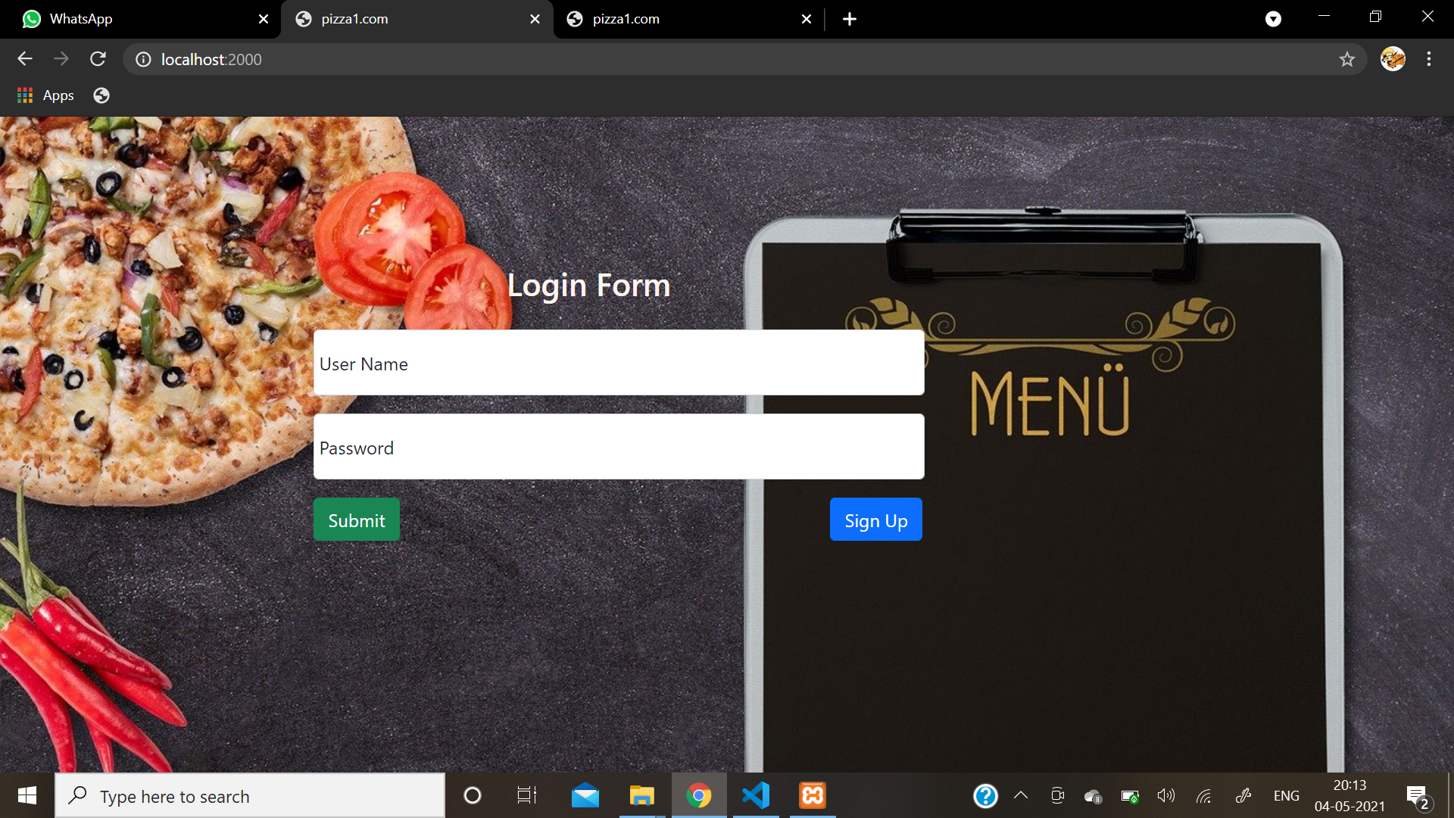

Sign Up

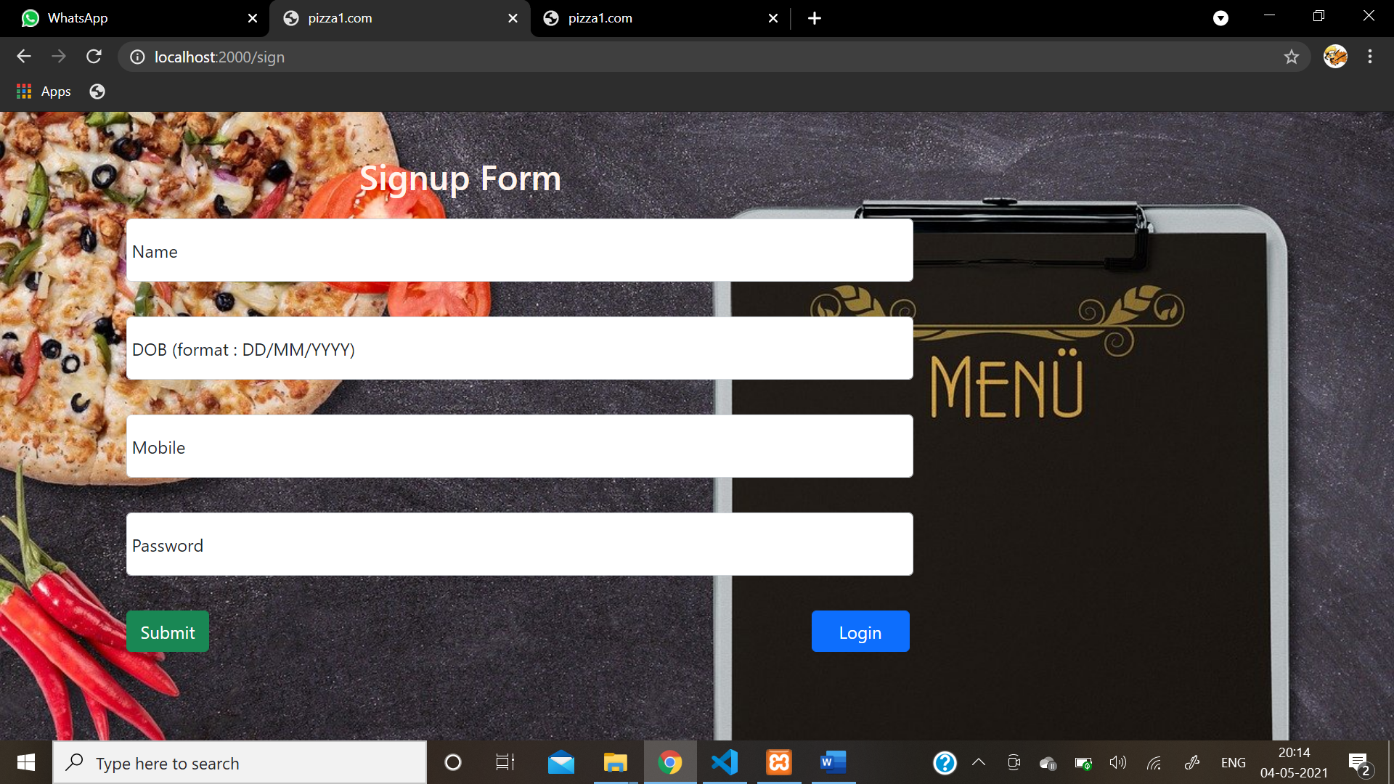

Home

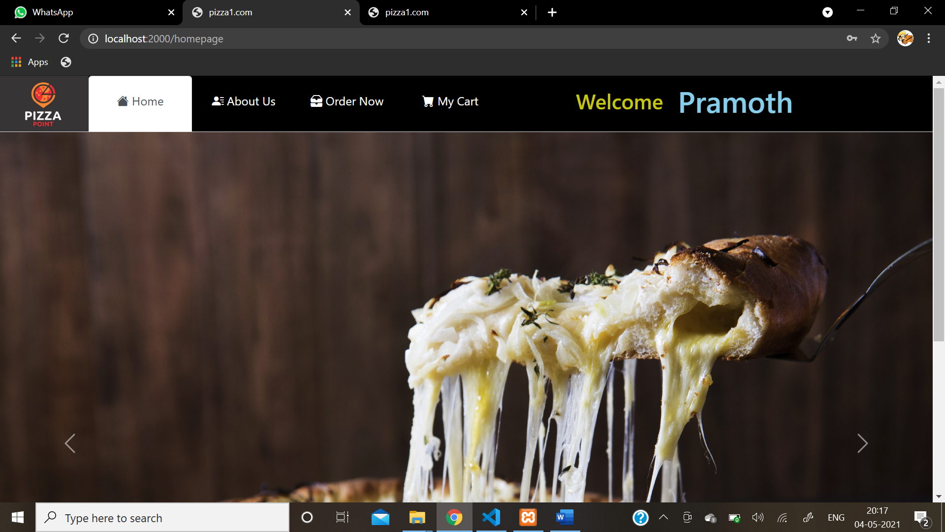

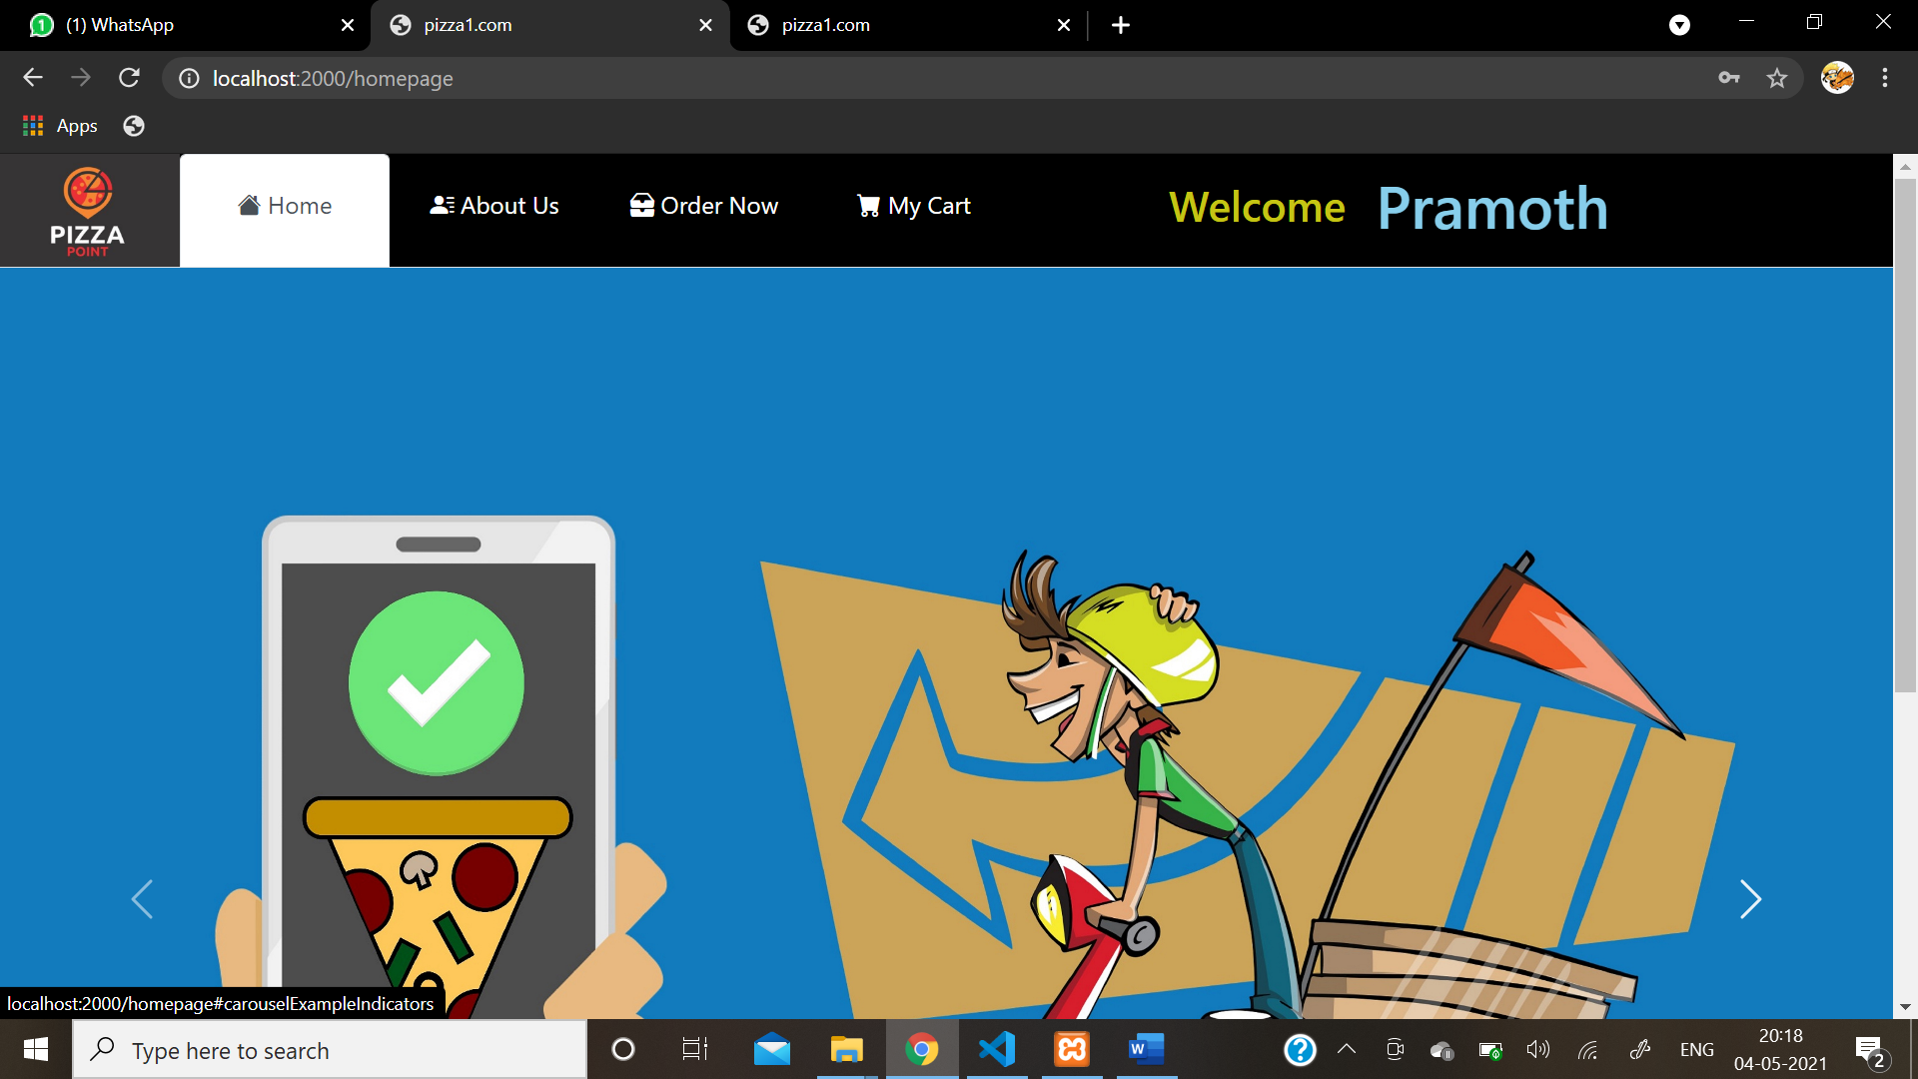

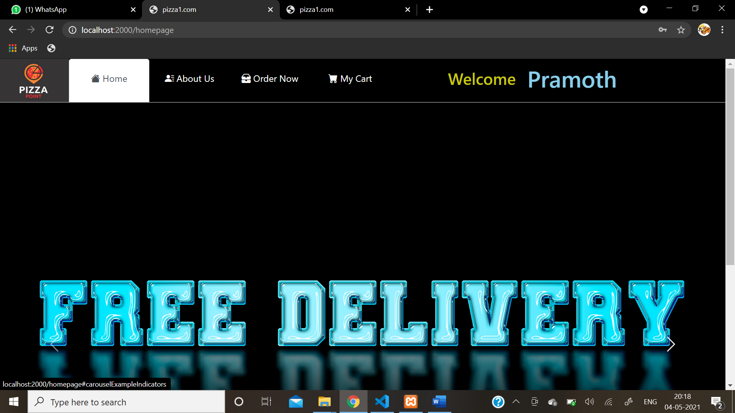

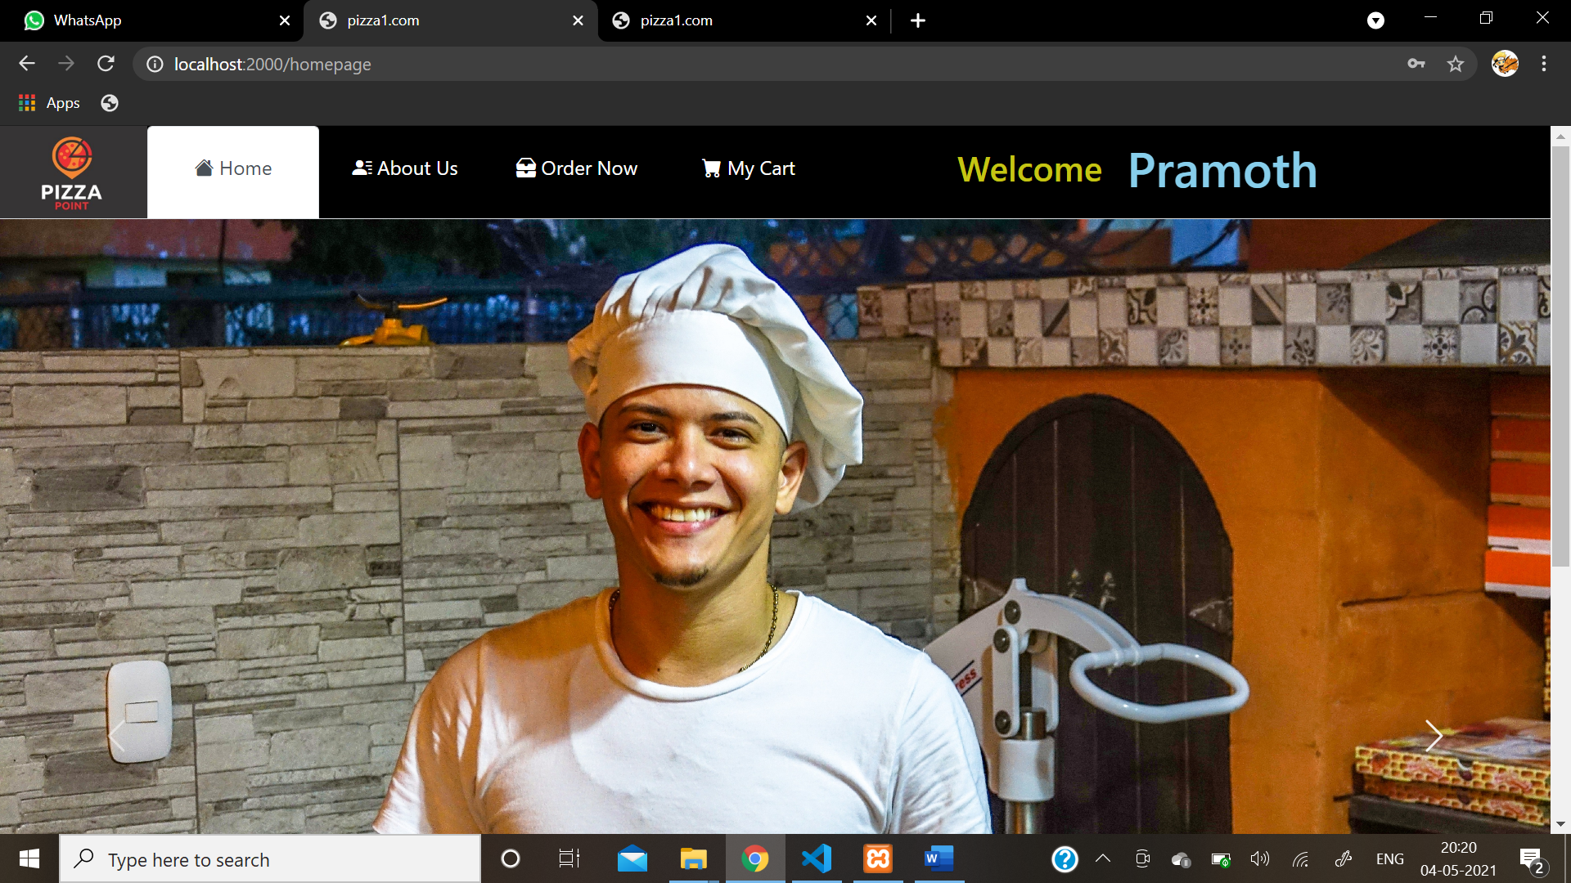

About Us

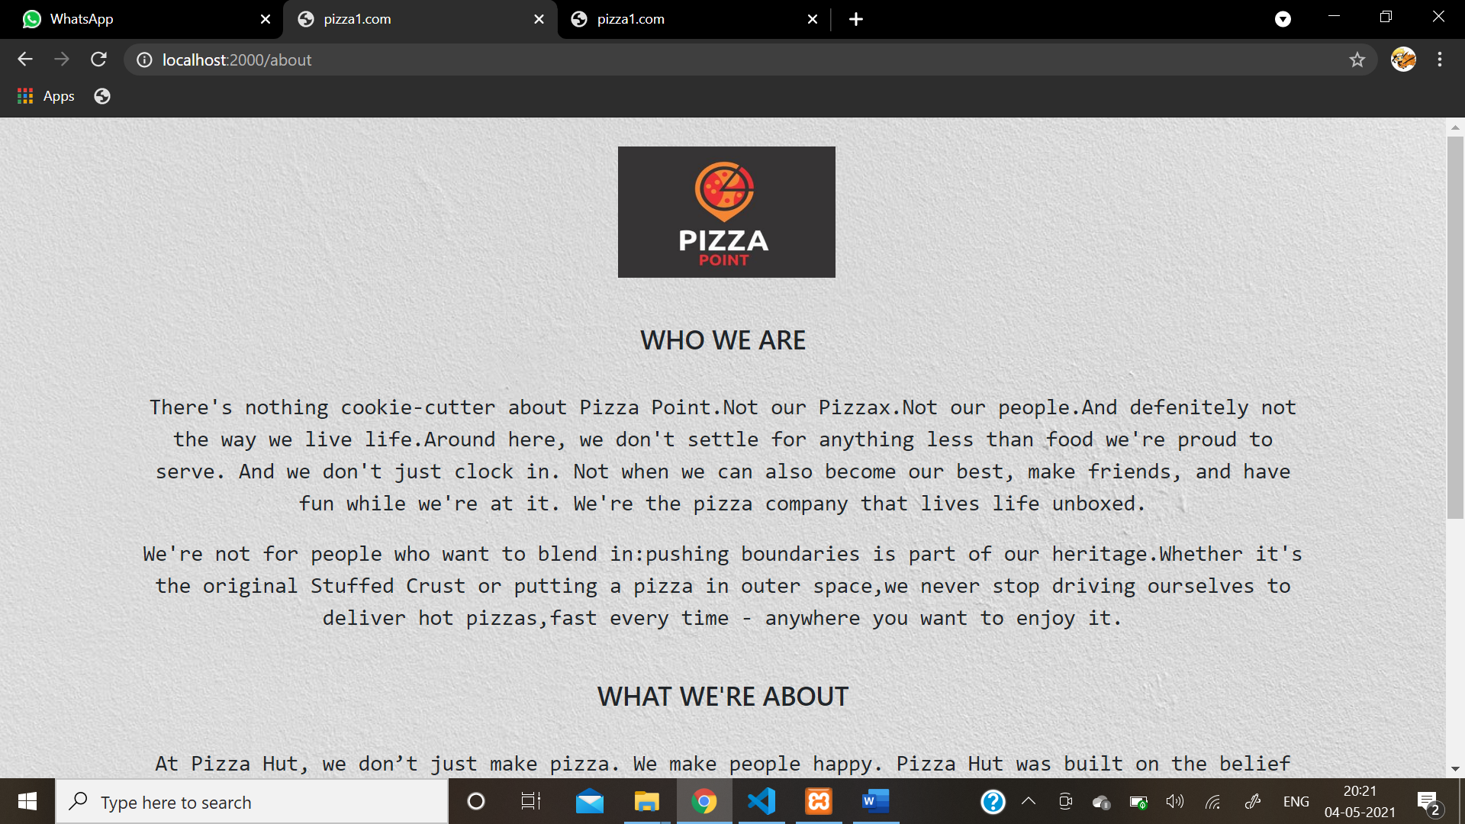

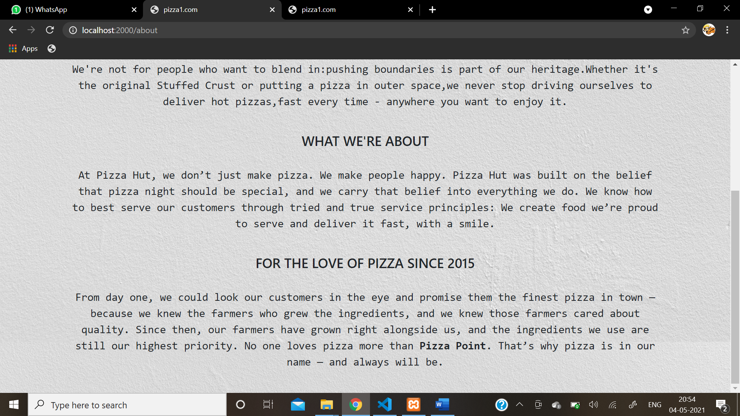

Products

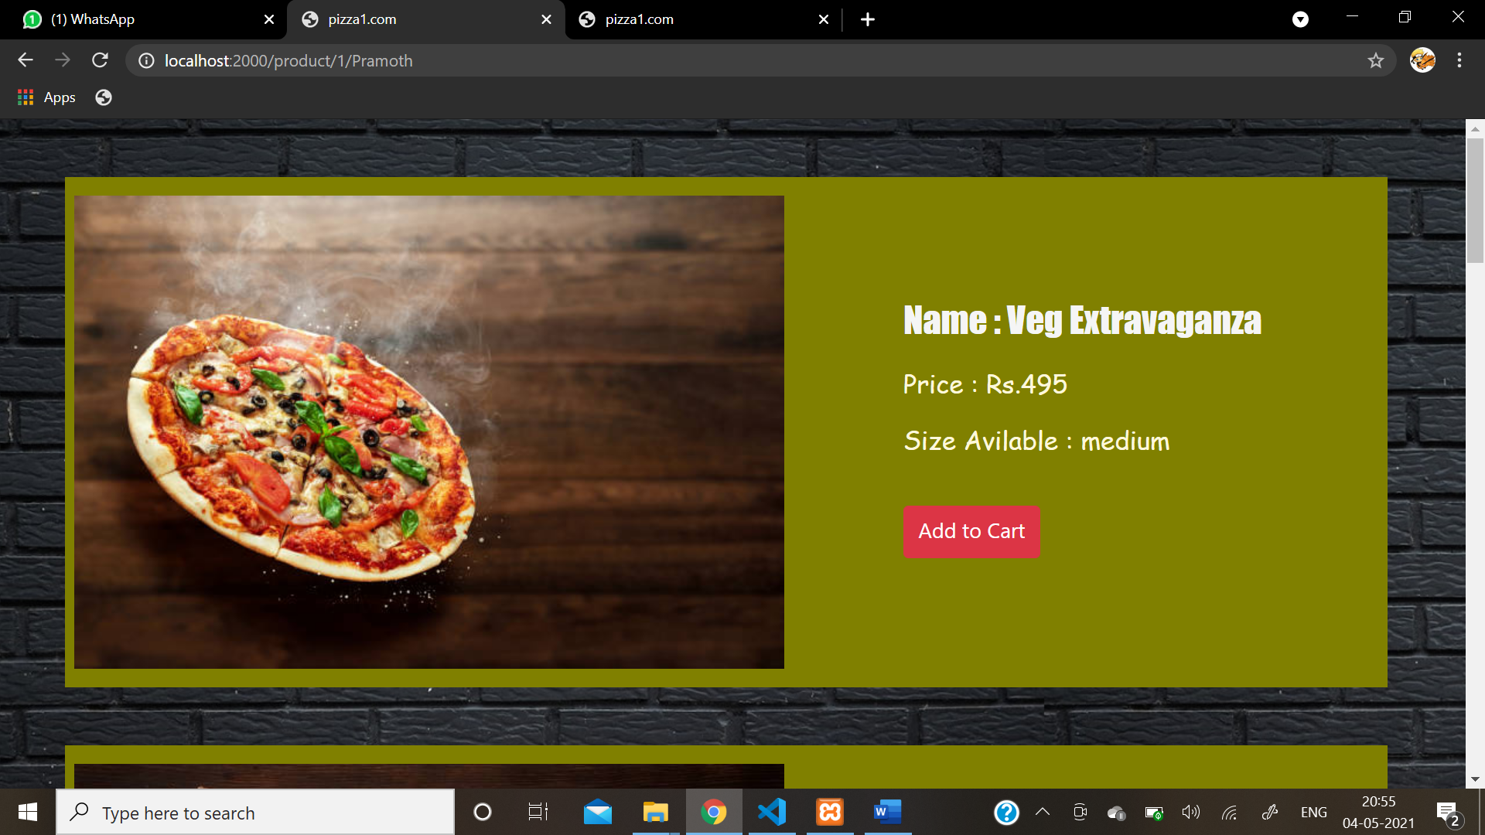

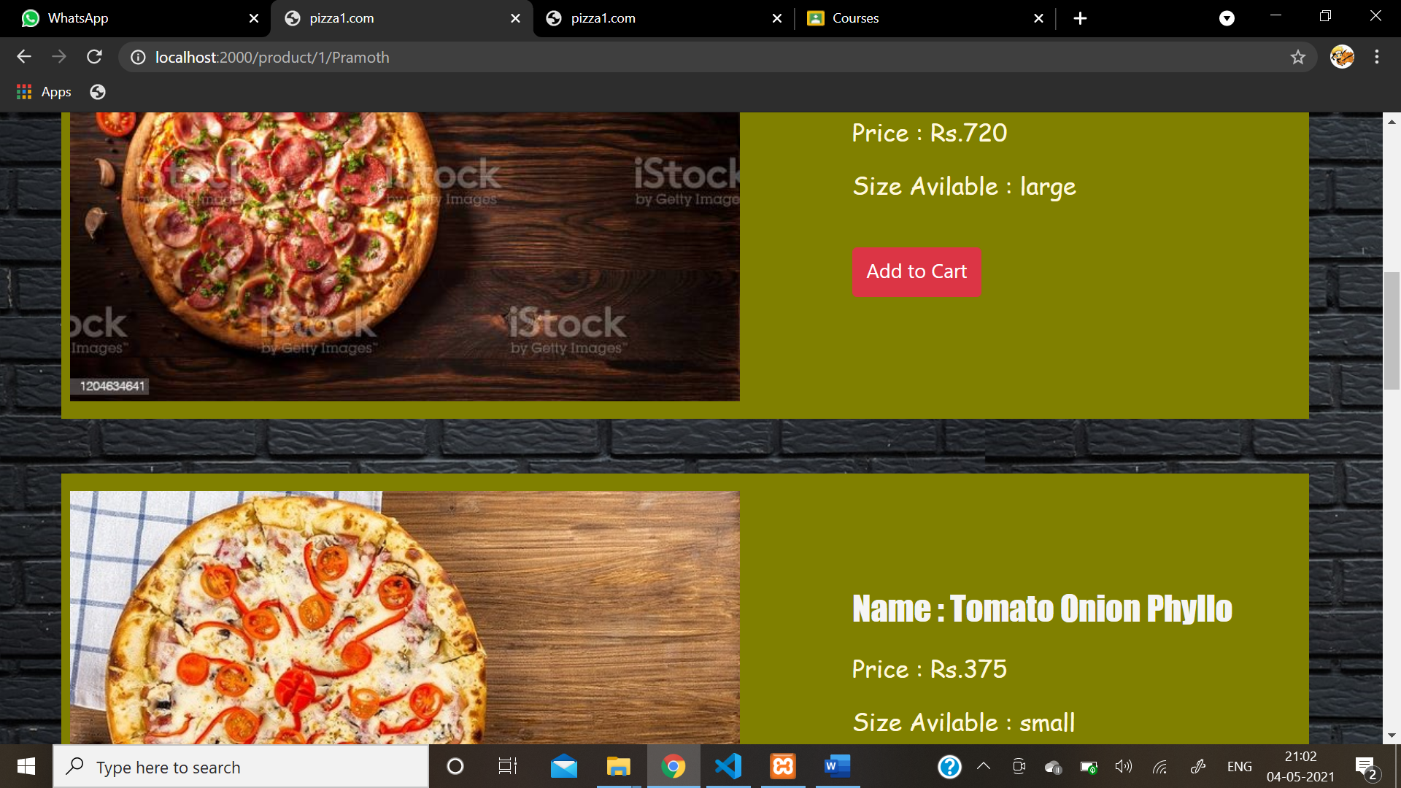

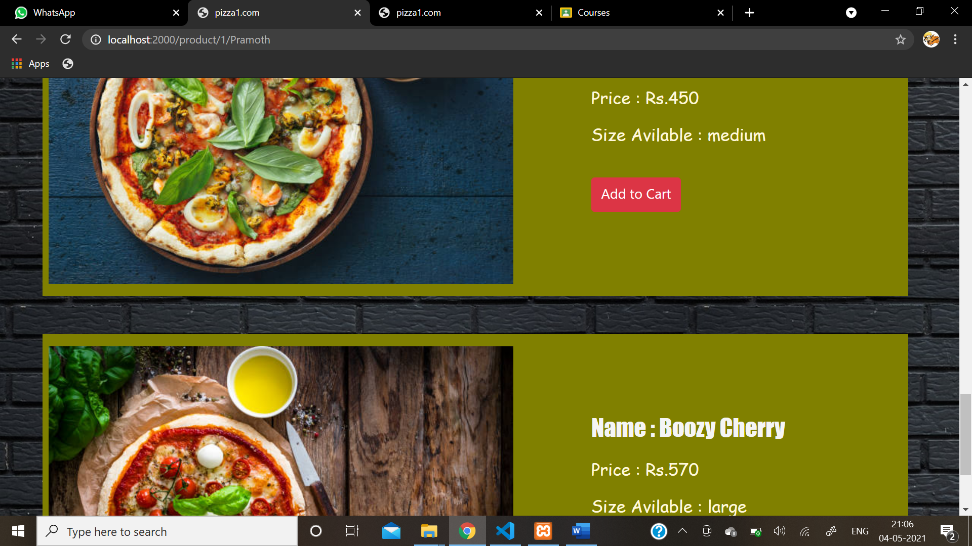

Confirming Order

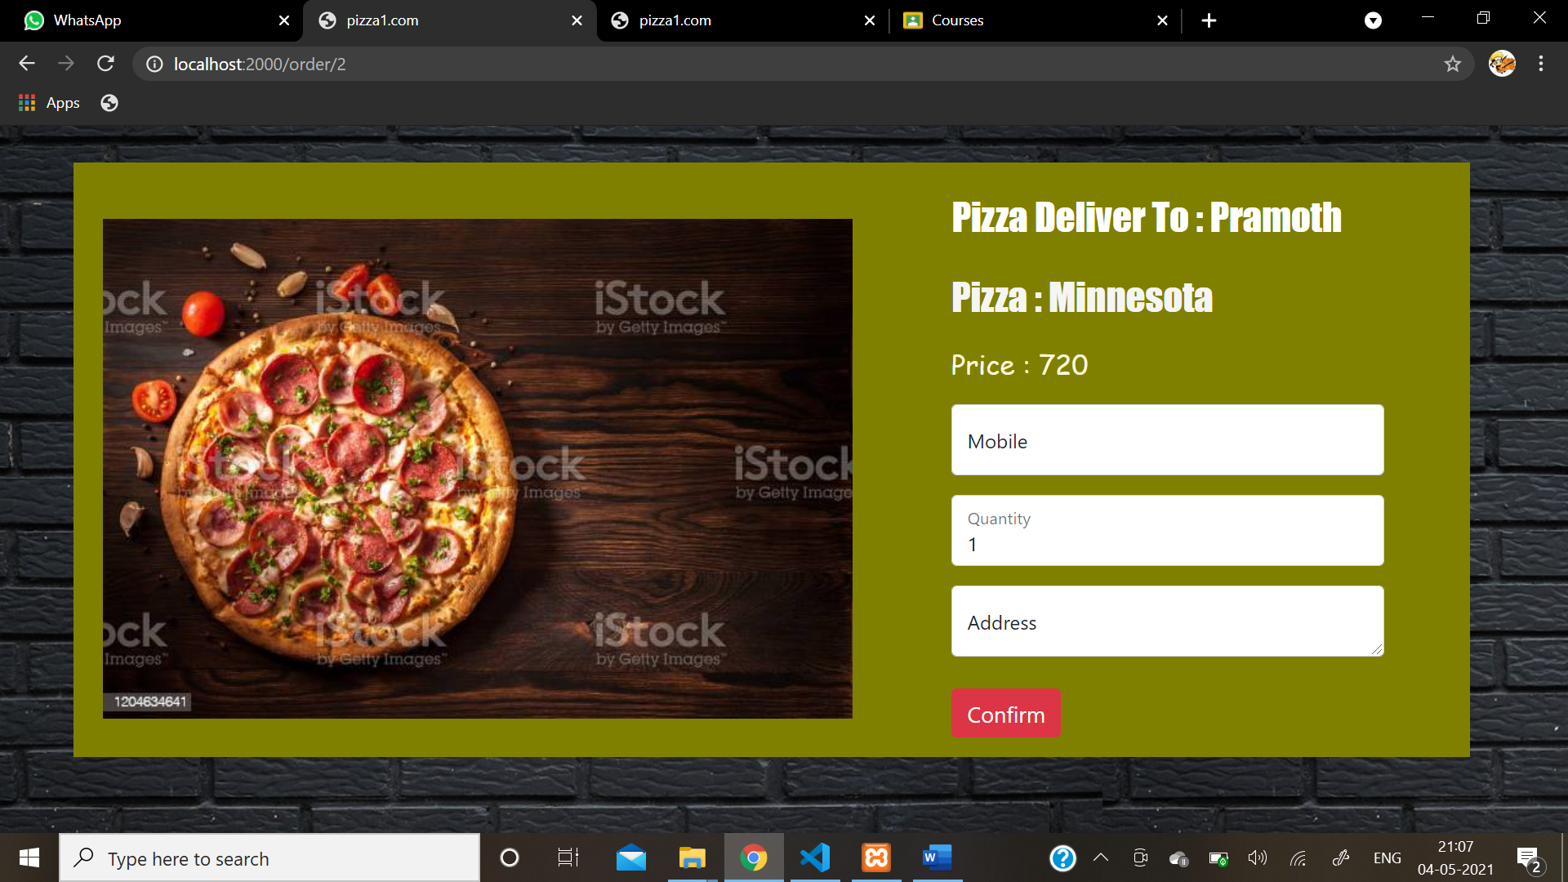

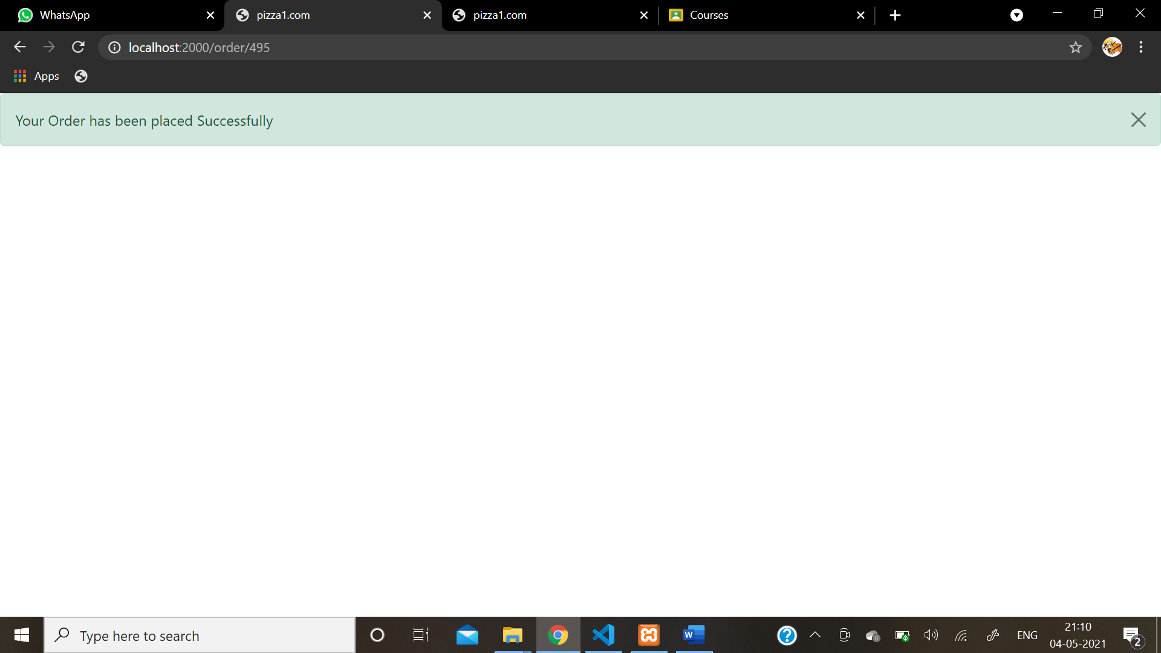

My Cart

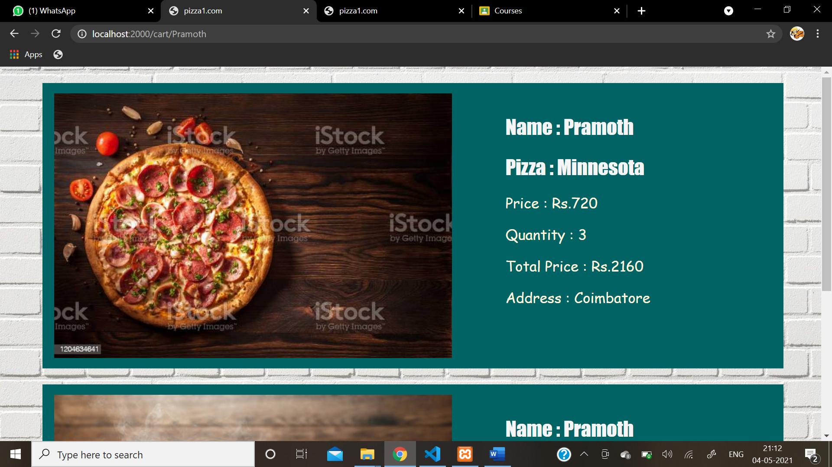

**ADMIN PURPOSE**

Login

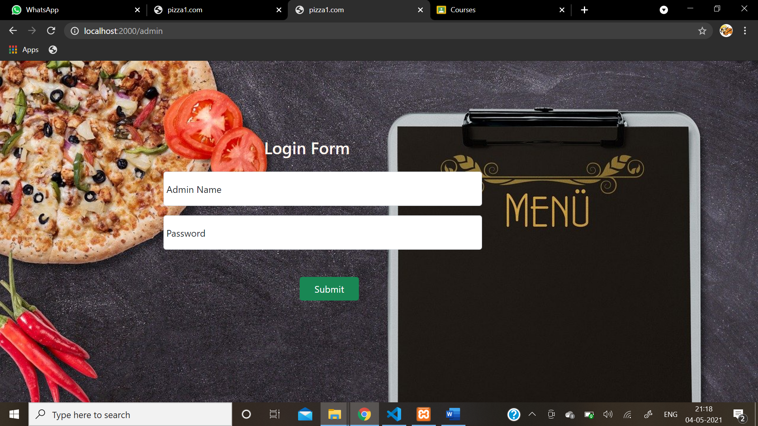

Pizza to be Delivered

